**Ex 9:Views**

create schema db;

create table Product(PID int,Pname varchar(10),cid int,price int);

desc Product;

insert into Product values(1,"chais",1,18);

insert into Product values(2,"chang",1,19);

insert into Product values(3,"hum",2,6);

insert into Product values(4,"butter",7,25);

insert into Product values(5,"chicken",3,30);

select * from Product;

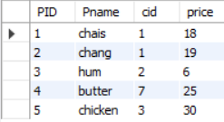

drop view ProductAboveAveragePrice;

create view ProductAboveAveragePrice as select Pname,price from Product where price>(select AVG(price) from Product);

select * from ProductAboveAveragePrice;

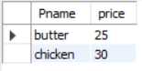

show create view ProductAboveAveragePrice;



drop view ProductAboveAveragePrice;